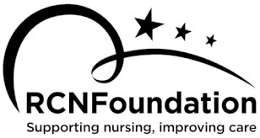

**Follow Your (Com)passion**

**Expression of interest**

Use this form to apply to participate in the project. We are looking for a group of participants representative of the full diversity of the workforce.

Please note that there are some basic criteria you must be able to fulfil.

* + - Approval from your line manager to participate in four two-hour Zoom calls between over a 12-week period. (The dates for these will be agreed once all twelve participants have been recruited to the project.)
    - You must be not more than 3 years post qualifying or registered in the UK if you trained and worked overseas.
    - Able and willing to share your experience candidly and to keep a diary (written, video or photographs) for the project.

|  |  |  |  |
| --- | --- | --- | --- |
| Name: | D.o.B: | | Email: |
| Mobile: | Address: | | |
| Job Title: | | | |
| Employer: | | | |
| Gender: | Ethnicity: | | Age: |
| In a few words, tell us a bit about you and why you are interested in participating: | | | |
| Is there anything at all we should know about what would help you participate? (Access needs, days when you are away or that are impossible to do, caring responsibilities etc.) | | | |
| Line Manager’s Name: | | Signed (Line Manager): | |

Please return this form to: [compassion@kingsfund.org.uk](mailto:compassion@kingsfund.org.uk)