 | What you said about Learning Disability Nursing
   | Martin Bollard talked with us about his Learning Disability Nurse project.  - This project is to find out how Learning Disability Nurses can stop people with a learning disability from dying early.  - The project also wants to know the difference Learning Disability Nurses make, so everybody knows more about what they do.  - This project also wants to know more about what Learning  Disability Nurses do to help People with Learning Disabilities when they go to the doctor’s, stay in hospital, and get the support they need in their homes.

 | At our first meeting, Martin told us what Learning Disability Nurses do and where they work.
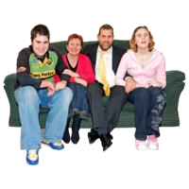    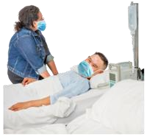   | - They work with families, other professionals and people with a learning disability.  - They help when people with a learning disability are worried before going into hospital.  - They help other nurses and doctors when people with a learning disability stay in hospital.  - They help when people with a learning disability leave hospital.
  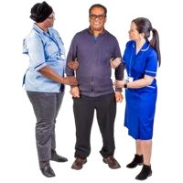   | - Learning Disability Nurses sometimes have to speak up when the needs of people with a learning disability are missed in hospitals.  - Learning Disability Nurses help staff at the doctor’s surgery work better for people with a learning disability.  - They make sure things get done after a health check.  - They give lots of training.

 | Where do Learning Disability Nurses work?
 | They work in many different places. They can work in your own home, in prisons or healthcare buildings.
 | At our second meeting we were reminded that:
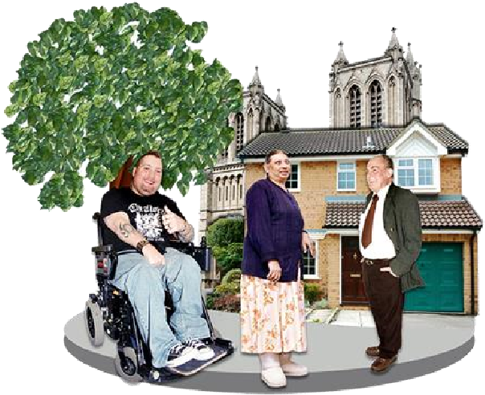 | Learning Disability Nurses often go into special schools, work in the community and go into people’s homes.

   | We were not sure:  - If Learning Disability Nurses work as part of the continuing healthcare team.  - Whether Learning Disability Nurses work in community learning disability teams and mental health teams.
 | We agreed there should be more information about what Learning Disability Nurses do.
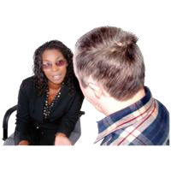 | • If people want to save lives, then they could be told how being a Learning Disability Nurse can do that.

 | - Learning Disability Nurses should be able to support people to live well in their own homes.  - How can we encourage people to become Learning Disability Nurses?
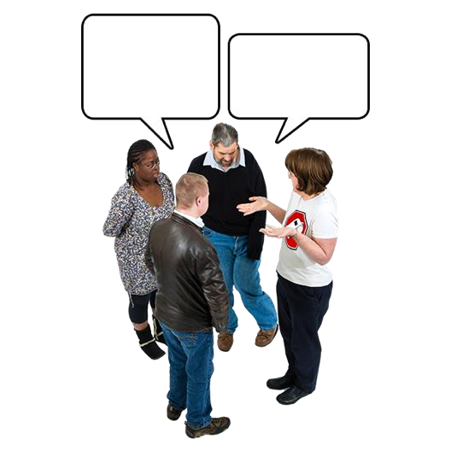 | We told Martin that we think Learning Disability Nurses can help in these ways:
 | • Helping general nurses to stay up to date and have Easy read documents available. Helping people to be able to give consent and make informed decisions.

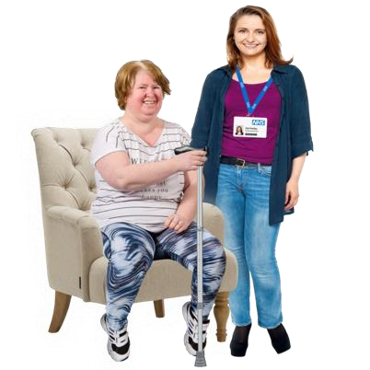  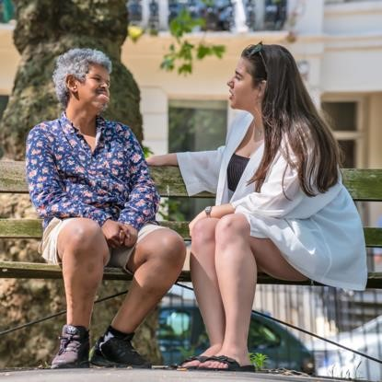   | - Helping to prevent health problems getting worse.  - Being part of the community more and understanding the problems people face.  - Social care providers do not always bring in healthcare providers to help people with a learning disability when they need to.

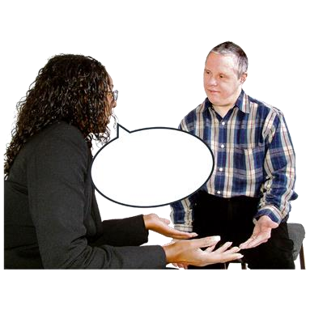 | - Supporting people after they have received a diagnosis for a learning disability and tell them what help they can get.  - They could support staff at the doctor’s surgery to be more welcoming and inclusive.
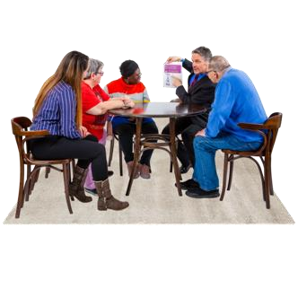 | We also told Martin that Learning Disability Nurses could make a difference by doing the following things:
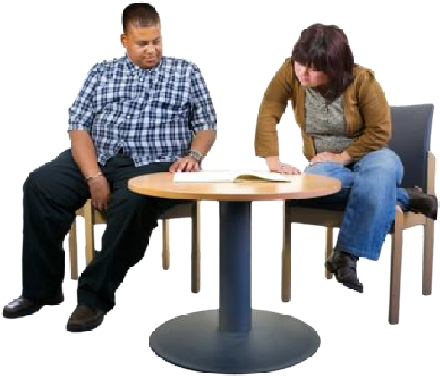 | • Making sure that a patient with a learning disability has everything they need.
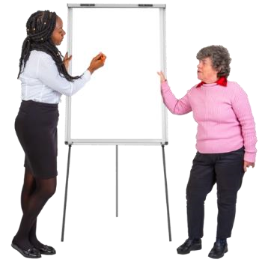    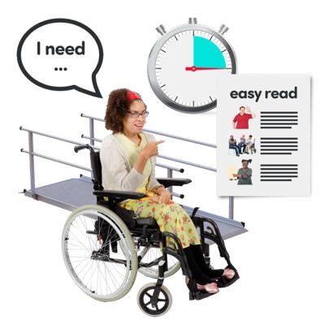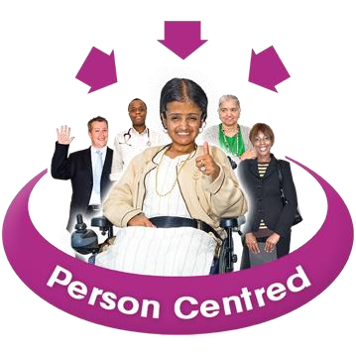 | - Helping nurses to think about the way they talk to people with  a learning disability  - Going to different services to help with reasonable adjustments.  - Being person centred.  - Showing other staff at the hospital how to support a person with a learning disability
  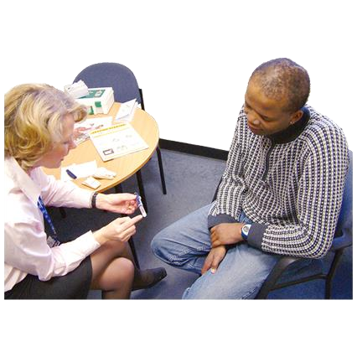     | - Helping the person to have a voice so they can ask staff to use Easy Read and simple language to explain what they mean.  - Meeting before an appointment to help the person understand what will happen and find out what they want to say at the appointment.  - Helping people to stay calm and feel less nervous or worried about the appointment or visit to hospital.  - Helping the person find the right words to explain how they are feeling.
 | - Helping to explain about any medication, what it is, how it works, how to take it and what the medication does.
 | Martin met the Workforce Advisory Group on 11 November.
 | We told Martin:  Most people with a learning disability do not know about the services they can get help from. How will Learning Disability Nurses help people get the services they need?
     | It would be good if general nurses visited self-advocacy groups to learn about Easy Read.  One of the group members had a bad experience with a general nurse. The nurse was not able to give them Easy Read information about autism. They had to get it from a self-advocacy group.  They had another bad experience where a general nurse raised their voice. The nurse thought that was the best way to talk to someone with a learning disability.  This group member thought that nurses should ask more questions
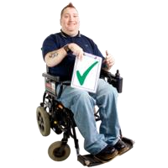     | about what people with a learning disability need.  Learning Disability Nurses should also help autistic patients.  One member said their experience of Learning Disability Nurses was very good.  They thought that they could go to their Learning Disability Nurse instead of a doctor.  They said the annual health check was really good.
  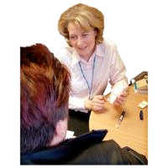 | One member said they were on a waiting list for a hip operation for a very long time. They wanted to know if a Learning Disability Nurse could help them put forward a case?  Another group member asked if a Learning Disability Nurse could teach them how to check their prostate.
 | Can a Learning Disability Nurse give counselling and help with mental health?
   | Martin and the group agreed that:  ALL nurses need to be better at using Easy Read.  Learning Disability Nurses should speak up so that general nurses don’t speak to people with a learning disability in the wrong way.  Learning Disability Nurses should help someone who is waiting for an operation. They should help them put forward their case better. They should help them deal with any pain.  Learning Disability Nurses should tell people about adaptable care.  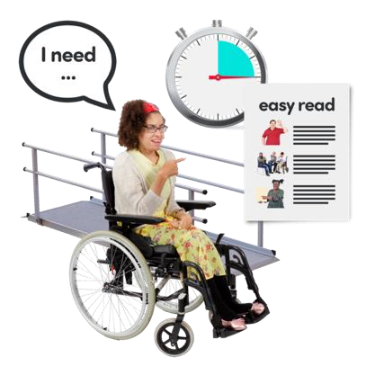  Adaptable care is when a care worker changes the way they work with people to help make it better for them.
 | Learning Disability Nurses should speak up for the patient when things do not go right.  Learning Disability Nurses should help someone check their prostate.  Learning Disability Nurses should help you know your rights.

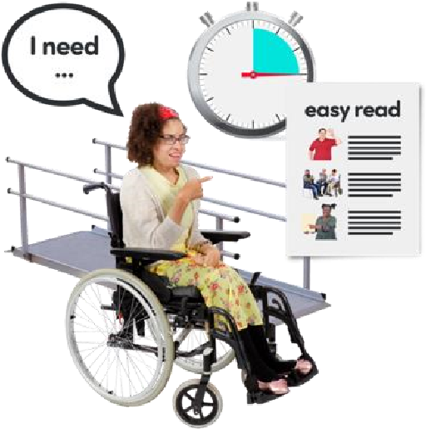  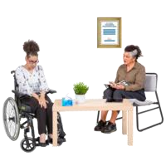   | Learning Disability Nurses should help people know what reasonable adjustments they can ask for.  Learning Disability Nurses should be trained in counselling.  Learning Disability Nurses should talk with Dental Nurses to help make a visit to the dentist better for a person with a learning disability.

