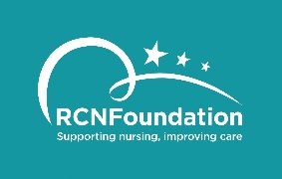

Equal Opportunities Form
Completion of this section is helpful to ensure that we are aware of the communities applying for this scheme and assists in the implementation of equal opportunities. This information will not form any part of the selection process and will be treated with total confidentiality.
(Please tick the appropriate boxes).
- Your Ethnic Group
Asian or Asian British | Mixed
- Indian | - White and Black Caribbean
- Pakistani | - White and Black African
- Bangladeshi | - White and Asian
- Any other Asian background | - Any other mixed background
- If other please state: | - If other please state:
Black or Black British | White
- Caribbean | - British
- African | - Irish
- Any other Black background | - Any other White background
If other please state: | If other please state:
- Chinese | Any other ethnic group
 | If other please state:
b. Your Gender  - Female  - Male  - Non-binary  - Transgender  - Other  d. Sexual Orientation  - Bisexual  - Gay  - Heterosexual  - Lesbian  - Other  e. Do you have a disability?  - Yes  - No | c. Your Age  - <20  - 20-29  - 30-39  - 40-49  - 50-59  - 60-69  - 70+  g. Where you currently live  - England  - Northern Ireland  - Scotland  - Wales  - Other

f. What Region:
- East Midlands
- Eastern
- London
- North West
- Northern
- South East
- South West
- West Midlands
- Yorkshire and Humber
- Northern Ireland
- Scotland
- Wales
- Other

