|  |  |  |  |
| --- | --- | --- | --- |
| Name: | D.o.B: | | Email: |
| Mobile: | Address: | | |
| Job Title: | | | |
| Employer: | | | |
| Gender: | Ethnicity: | | Age: |
| In a few words, tell us a bit about you and why you are interested in participating: | | | |
| Is there anything at all we should know about what would help you participate? (Access needs, days when you are away or that are impossible to do, caring responsibilities etc.) | | | |
| Line Manager’s Name: | | Signed (Line Manager): | |

Please return this form to: [compassion@kingsfund.org.uk](mailto:compassion@kingsfund.org.uk)no later than 5pm on 28th February 2023.

We will be scheduling calls thro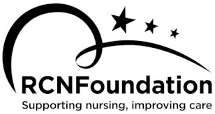ughout February to shortlist participants and will reply to your expression of interest as soon as we can after you submit it.

**Follow Your (Com)passion**

**Expression of interest**

Use this form to apply to participate in the project. We are looking for nurses representative of the full diversity of the nursing workforce.

Please note that there are some basic criteria you must be able to fulfil.

* + - Approval from your line manager to participate in six two-hour Zoom calls between 2pm-4pm over a 12 week period. (The dates for these will be agreed once all twelve participants have been recruited to the project.)
    - You must be not more than 3 years post qualifying.
    - Able and willing to share your experience candidly and to keep a diary (written, video or photographs) for the 12 week life of the project.