Inclusive Health - Enhancing the lives of individuals with learning disabilities in the Western Trust

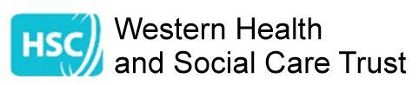



This Easy Read booklet tells you how we want to make hospital Emergency Departments better for people with learning disabilities

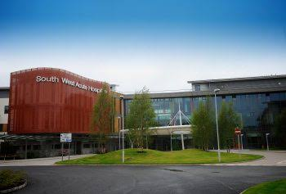
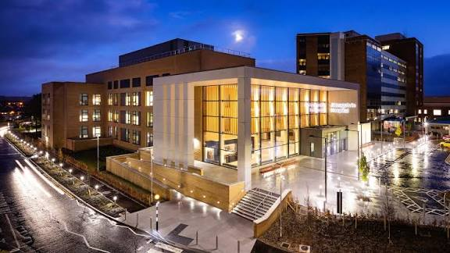

The Western Health and Social Care Trust has two hospitals.
Each hospital has an Emergency Department.

People with a learning disability can go to either hospital.

We know hospitals can be stressful.
We want to make this easier for everyone

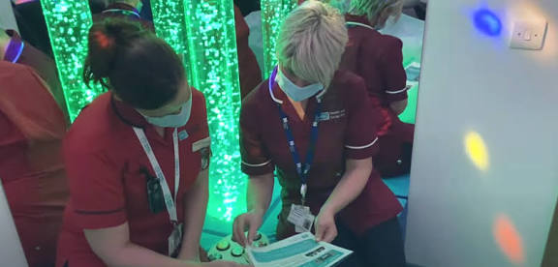

Each hospital has a learning disability nurse who helps support good health outcomes

There are quiet sensory rooms in each of our emergency departments

We use special care plans and Hospital Passports to help staff understand what people need

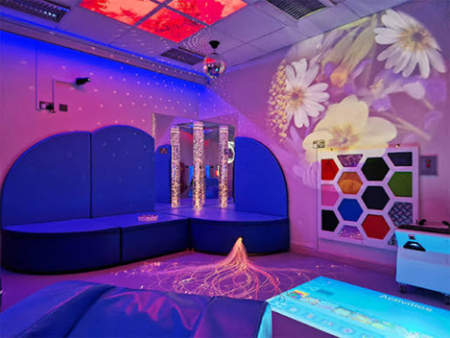

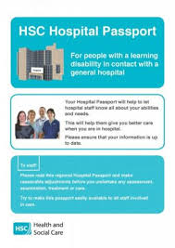
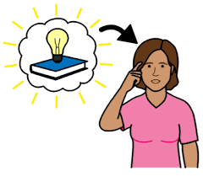
We want to make things even better in our emergency departments.

We will create a toolkit to help people with learning disabilities when they come to the Emergency Department.

The toolkit will make sure people get the right care at the right time.

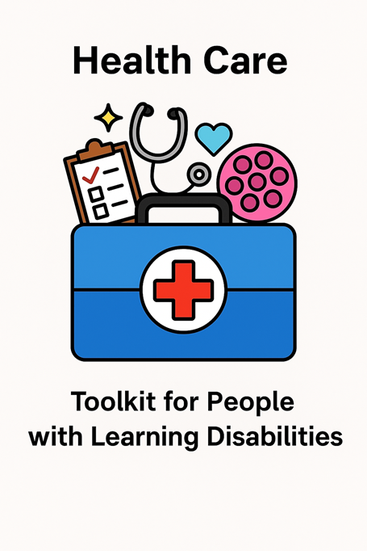
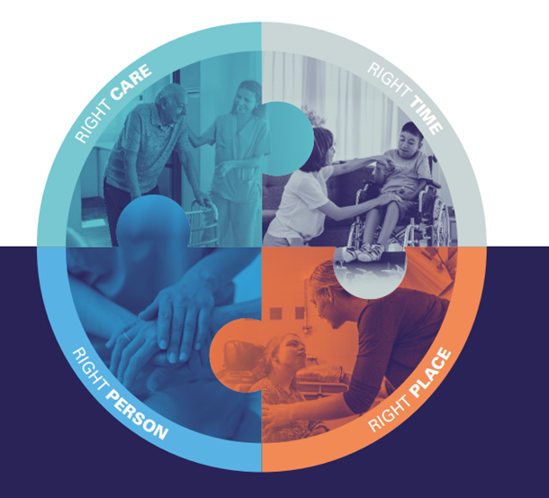


We will work together to make the toolkit.

People with learning disabilities, carers, and staff will share ideas.

We will listen to what everyone says.

.

Speech and Language Therapists will help us.

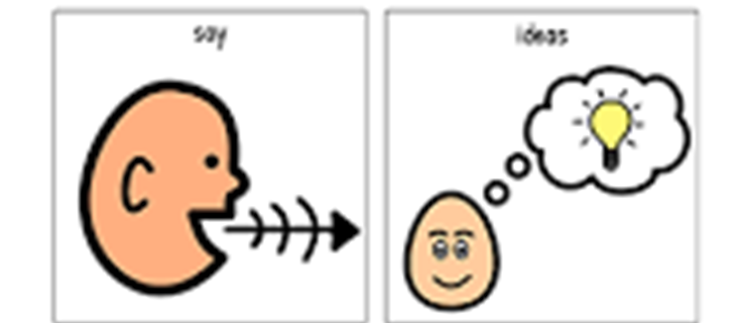
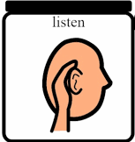
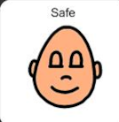
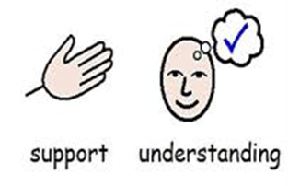
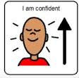
People with learning disabilities will feel safe and welcome.

Families and carers will feel supported.

Staff will feel confident and proud of their care.

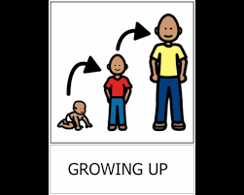
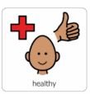
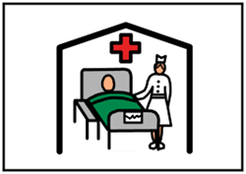
The toolkit will help people access the hospital easier

Stay healthier

Live longer

