What this research is about?

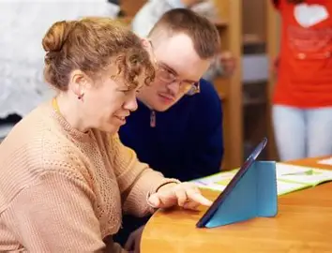 | We want to learn how Learning Disability Nurses in Wales support people with a learning disability when they are dying or reaching the end of their life.
Why do we need to do this research?

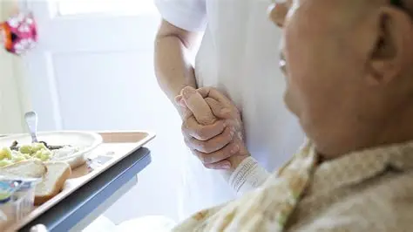 | Many people with a learning disability do not get the right support when they are dying.
 | We want to understand what good care looks like.
 | We also want to find out what makes good care hard.
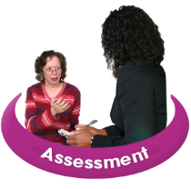 | We want to find out how learning disability nurses can support people with learning disabilities at the end of their life
What will we do?

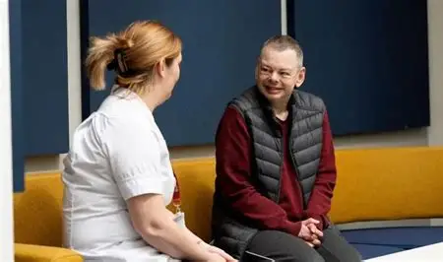 | Interviews with learning disability nurses working in Wales
 | Online group question and answers with:  - Learning disability nurses that work with people at the end of their life  - nurses that visit people in their homes (district nurses)  - other nurses that have worked with people with a learning disability at the end of their life.  These groups are called focus groups and nurses can answer the questions when they have time. The focus groups will be open for an agreed time.
 | We will listen to nurses to:  - find out about what they do to support people with learning disabilities  - what they do to support people well  - find out what needs to change.
Who much money do we need?

 | We are asking for £29,134 to carry out this research.
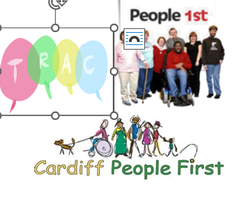 | £5000 of this will pay for work completed by TRAC and Cardiff People First members.
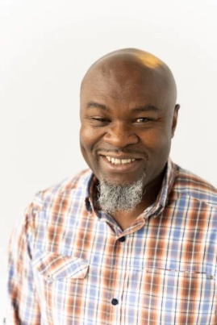 | £23,134 will pay for a research assistant to carry out the research.
 | £1000 will pay for any printing, easy read materials, and publishing the research in a journal.
Who will be working on this?

 | We will be carrying out this research with members of Cardiff People First and TRAC. This is very important to us. They will help make sure that the voice of people with learning disabilities is heard across the research process and when sharing the findings.
 | Stacey Rees will be the lead researcher.  Stacey works at the University
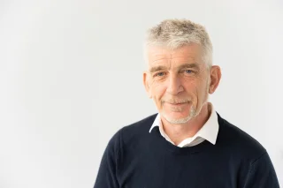 | Stuart Todd will support Stacey with the research.  Stuart works at the University too
 | Ed Oloidi is a research assistant at the University of South Wales
 | Sophie Besent is a learning disability nurse.  Sophie works as a community learning disability nurse
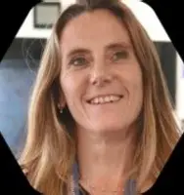 | Bethany Kruger is a learning disability nurse and now works as a Senior Improvement Manager in the NHS
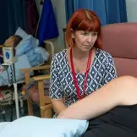 | Maria Parry is Programme Manager for End-of-Life care in NHS Wales.
What will happen with what we find out from the research?
 | We will write a report with the findings and share this.
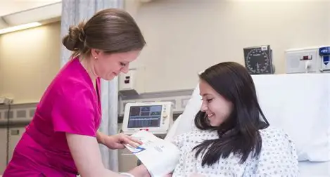 | The findings will improve nursing practice
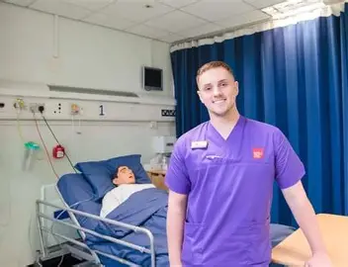 | The findings will help us improve the teaching we give to student nurses  The findings will help improve Welsh Government policy
 | The findings will also provide us with more research about learning disability nursing.
 | Most importantly, the findings will help people with learning disabilities in Wales get person centred end of life care.
 | Thank you for reading – please let us know if you need any further information.

