BOWEL CHART

NAME: NHS Number:

DOB: Address:

What happens when you go to the toilet? Please complete this chart to help us assess your bowel symptoms.

Date & time | Bristol Stool Type  see below | Accident/Soiling | Did you want to go?  Yes/No | Remarks  e.g. blood, mucous, unusual colour, straining, pain, feeling of incomplete emptying, amount of leakage / incontinence, relevant oral or rectal medications

Bristol Stool Types:

Type 1  Separate hard lumps, like nuts (hard to pass) | Type 2  Sausage shaped but lumpy | Type 3  Like a sausage but with cracks on its surface | Type 4  Like a sausage or a snake, smooth and soft | Type 5  Soft blobs with clear-cut edges (passes easily) | Type 6  Fluffy pieces with ragged edges, a mushy stool | Type 7  Watery, no solid pieces, entirely liquid
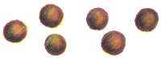 | 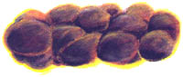 | 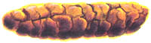 | 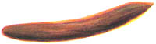 | 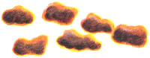 | 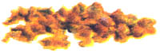 | 