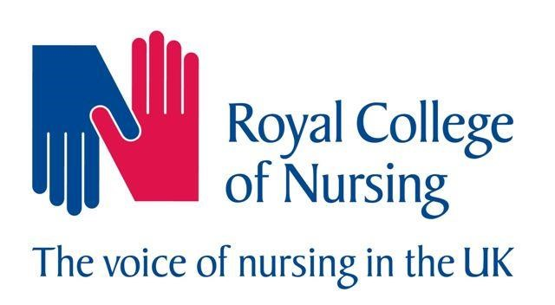

Public Health placement experience.

Please use the following to provide details of your experience in a public health placement. This template is intended as a guide so please adapt if necessary.

Name
University / Higher Education Institution
Include contacts as applicable at the university / placement
Speciality/setting
i.e: local authority charity health protection
Would you be happy for your photograph to appear on the RCN website?

This template is intended for students to complete but could equally be completed by the placement and or university or as a combination.

Introduction: - Tell us a little about you, what stage of training are you, what branch of nursing? Tell us about the placement where it was, geographical area and local demographics?

Did you and the placement / university use the RCN tool to help design the placement and help identify learning opportunities.
What was the best thing about the placement?
What did you find the most challenging aspect of the placement?
How do you intend to use the learning from this placement for future placements?
What would have helped make the placement better?
Are there any aspects of the RCN tool which could be strengthened?
What is your long-term career plan?

Please return this form to Professional lead for public health nursing helen.donovan@rcn.org.uk

