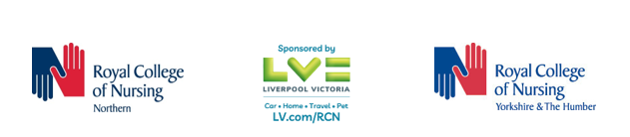
Nomination for RCN Northern and Yorkshire and Humber

Winning nominations will be announced at our Black History Month event on Friday 21st October 2022. The event will talk place between 9.30am and 4.30pm in the Theatre, The Catalyst, 3 Science Square, Newcastle Helix, Newcastle upon Tyne, NE 4 5TG

Nomination
1. | Submitted by:
2. | Email contact:
3. | Category:  Individual / Team / University/ Organisation
4. | Name and contact details of nominee(s)
5. | Tell us what they did, how and why.
6. | Describe any challenges, if known, that they faced and how they overcame them.
7. | Explain what impact their work had. This might include examples, facts and figures.
8. | Tell us what it was about this person, team, university or organisation that inspired you.

Nominations are open from 1 June 2022 and close at 5pm on 31 August 2022.

Nominations will be judged by panel of judges:

Sarah Dodsworth, RCN Regional Director

Gavin Stroud from our sponsor company LV=

Ifrah Salih, Senior Lecturer in Academic Development and Diversity, Sheffield Hallam University
Alan Chalkley, RCN Library and Archive team, Northern, Yorkshire and Humber, North West regions
Chairs of the Regional Boards – Northern and Yorkshire and Humber

Anyone unable to collect their award will be sent it after the event has taken place on 21 October 2022.

Please return your completed nomination form to: yorkshire.andhumberregion@rcn.org.uk and type Nomination in the title field. Only entries received by 5pm on 31 August will be considered.

Please email emma.phillips@rcn.org.uk if you have any queries.

Thank you

