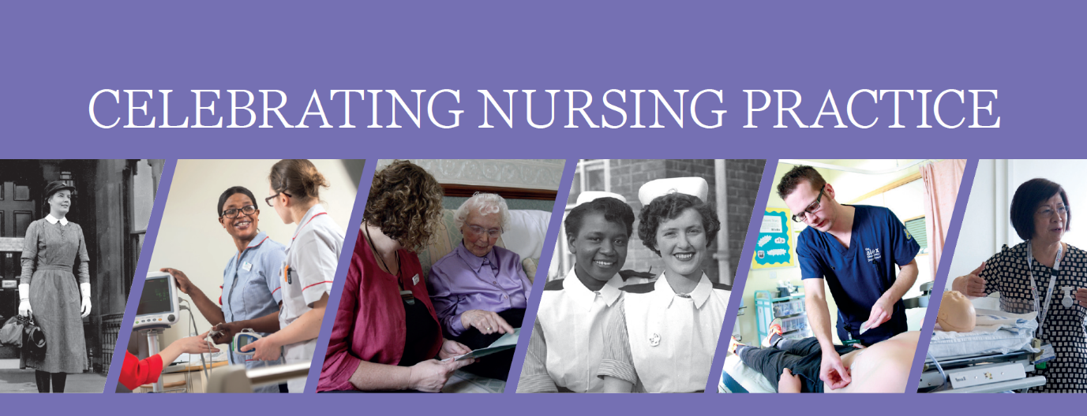

The Celebrating Nursing Practice project forms part of the RCN centenary celebrations. All the participants’ contributions will be used to produce an online publication of good practice and innovation, showcasing the very best of the profession.
This template will be used to create the article about your contribution to the project. We want to ensure we give your work the best write up we can so please include as much detail as possible. If you have any questions get in touch with us at celebratingnursingpractice@rcn.org.uk
Please include your contact details below, so that we can contact you for further information should we need to whilst we create the publication.
Name:
Title of Project:
Email:
Telephone Number:

Please include a picture for the publication. This can be project related, or a professional looking profile picture. Ideally this would be good quality photographic images, with dimensions of at least 1200 x 800 pixels as we may not be able to use low quality and/or small images.
Please complete each section to the best of your ability. Max word count 250 words unless stated.
Provide a brief summary of your project and how it will be beneficial to nursing/patients/public

Max word count 750 words
Please tell us how you have progressed your project since submission.

List your aims and objectives, activities, outputs/what you have achieved and lessons learned.

Think about your initial objectives and how your progress links back to them, highlighting what you have achieved and any challenges you faced.

Aims/Objectives:

Activity:

Outputs:

Lessons learned:

Any activity that was unachievable and why:

Explain the impact it has had or will have on patients/ service users and the overall service provision.

How do you know it had an impact (how did you measure/monitor impact)

Are there outcomes from this project which can be implemented more widely? If yes, how can this be achieved?

How do you intend to sustain the momentum and embed the project into daily practice?

What financial support would you need to continue to successfully develop and support your project? Please give a breakdown of resources required, to the best of your ability, including rationale of need and cost.

Will you need additional financial support in the future to sustain your change? If yes please explain how you intend to fund this.

Is there anything RCN could do to help with this outside of financial assistance?

The next phase of the Celebrating Nursing Practice project will see up to three projects taken on for further development. Funding will be available (up to £3750 per quarter depending on bid/rationale behind expenditure) and this can be used to increase the scope of your project, for wider implementation or for evaluation purposes.
Those selected for further development will be offered a place on the RCNs Demonstrating Value Masterclass. This one-day course teaches the application of the principals of economic assessment in practice. The learning outcomes include:
- Understand how to identify your stakeholders.
- Create a visual representation of your service.
- Understand how to effectively communicate the value of your service.
- Learn about different approaches to economic assessment.
- Learn how to have informed discussions with key stakeholders and ensure your economic assessment has the desired impact.
- Learn how to apply the principles of economic assessment in practice to demonstrate the true economic costs and the benefits of your service.
- Produce a case study to share with your key stakeholders to inform decision making.

Please indicate whether you would like your project to be considered for this next phase.
(Y/N)

If yes, tell us why you think your project would be a good candidate for further development.

Thank you for all your hard work on this project so far. We look forward to producing the online publication and sharing with you and the wider RCN community.

We’ll be in touch should we have any further questions about your project.

