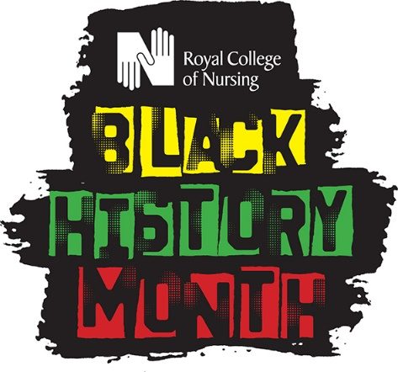
BLACK HISTORY MONTH 2021
Making A Difference Award: Anti-racism – a moment for literacy and transformation

As part of our Black History Month 2021 celebrations, the Royal College of Nursing in the Eastern, East Midlands and West Midlands regions are holding a combined event and would like to invite you to nominate an individual who has made a real difference to the lives of Black, Asian and Minority Ethnic colleagues or patients through the delivery of health and/or social care.
The individual you nominate must be from the Black, Asian and Minority Ethnic nursing community, or someone who has been an ally and who has made a real difference on behalf of patients or on behalf of Black, Asian and Minority Ethnic colleagues from the nursing community. Your nominee may have been proactive in taking action to make a difference for patients or colleagues.
The theme of this year’s celebrations is ‘Anti-racism, a moment for literacy and transformation – got to do right, got to do anti-racism’, so we would also really welcome nominations for colleagues who have been proactive in the course of their everyday roles on the issue of race equality, inclusion and anti-discrimination.
The Making A Difference awards are an opportunity for you, your colleagues, and the RCN to recognise and reward nurses, nursing support workers and midwives for Making a Difference and we welcome nominations from all sectors, not just the NHS.

How to nominate a candidate:

Nominate someone who works in the Eastern, East Midlands or West Midlands region who:
- is from a Black, Asian, and Minority Ethnic background who may work with Black, Asian and Minority Ethnic communities; or
- is an ally of Black, Asian and Minority Ethnic colleagues and communities in the course of their work
- works in a nursing role across bands 2-7, or role equivalent
- is key to the future of nursing (locally and/or nationally)
- is a member of the RCN.

Please submit your nominations by midnight on Sunday 29 August 2021.
Due to the current challenges around Covid-19 there will not be a physical award ceremony this year. Instead, the recipients of the 2021 awards will receive a prize and their contribution will be recognised at a live Black History Month event taking place on 12 October 2021.
With their consent their contribution will also be publicised across RCN social media channels during Black History Month.
Email your completed nomination form to your Regional Office:
RCN Eastern: eastern.region@rcn.org.uk
RCN East Midlands: eastmidlands.region@rcn.org.uk
RCN West Midlands: westmidlands.region@rcn.org.uk

Nomination Form
Nominator
Your name:
Email:
Tel. no:
Job title:
Workplace:
Relationship to nominee (e.g. line manager):

Nominee
Name:
Job title:
Band/level (bands 2-7, or equivalent):
Is s/he/they from a Black, Asian, or Minority Ethnic background? Yes/No
Nominee’s Email Address:
Nominee’s Tel Number:

This year’s Black History Month theme is ‘Anti-racism, a moment for literacy and transformation’ so if you can, please consider how the achievement of your nominee fits this theme.
- Has the member challenged language used to address Black and Ethnic Minorities and explained why it was inappropriate or outdated?
- Have they empowered themselves or have they empowered others? This could be patients, service users, residents or colleagues.
- Presence: e.g. have they shown leadership in their workplace or community? Do you think they will play a key role in the future of nursing (locally or nationally)?

You may also want to consider if their work has:
- improved care for patients, service users or residents
- led to innovation in nursing
- developed or improved a service
- supported colleagues during difficult times (e.g. COVID-19).
Reason for Nomination
Please explain your reason for the nomination below (maximum of 250 words):

