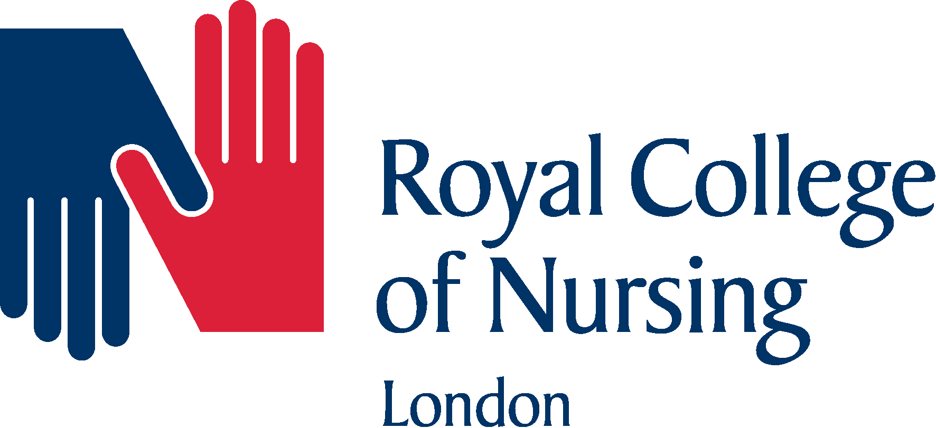

An RCN Event from the Inner and Outer South West London Branches
Lecture Theatre (Post Graduate Medical Centre)
Croydon University Hospital

9.00 - 9.30 Registration and Refreshments

9.30 - 9.50 Welcome from Cynthia Davis, Chair RCN London Board - introduction to the
Day; Branch info by Branch Chairs Mike Smith & Pat Yiggon

09.50 - 10.35 Dementia and Delirium - Moira Rowan, Specialist Nurse in Delirium and
Dementia at St George’s Hospital and Nicola Zimmermann linked with the
Alzheimer’s society

10.35 - 10.45 Comfort Break

10.45 - 11.00 Michael Fanning, Director of Nursing, Croydon University Hospital

11.00 - 11.30 Keynote speaker, RCN President, Cecilia Anim

11.30 - 12.00 Sustainability and Transfer Plans for South West London - Charlotte Gawne,
Director of Communications, Louise Fleming , Director Quality and Karen Broughton, Director of Strategy, NHS South West London Alliance (Kingston, Richmond, Merton and Wandsworth CCGs) and South West London
Sustainability and Transformation Plan

12.00 - 13.00 Lunch Break - LV stand with Gavin Stroud, RCN stand + RCN information
point - opportunity to talk informally with RCN staff and local reps

13.00 - 13.40 Stress management and other RCN membership support services -
Kate Bridle, Lamplight Support

13.40 - 14.00 Benefits of RCN membership, Pay and other RCN campaigns; Becoming active
as a representative (may show a film here)

14.00 - 14.40 Sepsis - Sharing expertise through education
Theresa Weldring - Sepsis Group leader - Kingston Hospital Trust

14.40 - 15.00 Comfort Break

15.00 - 15.40 End of Life Care post the Liverpool Care Pathway -
Caroline Adams, Clinical Nurse Specialist, Palliative Care, Croydon Hospital

15.40 - 16.00 Summary of the day and formal close - Cynthia Davis and collect feedback forms

