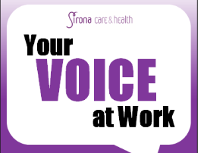
Trade Unions @ Sirona

Pay negotiations, member feedback form
You will be aware that Sirona have awarded staff a 1% pay increase from the 1st October. Staff have been advised they should see this increase in their pay on 24th October, however, there are no current plans to backdate this increase to last April. This increase will go ahead, however your staff side union reps have raised the issue with Sirona senior leadership that future pay increases should be negotiated though joint partnership meetings, giving us the opportunity to consult with our members and get your feedback and views on any pay deal offered.
As part of this process we, at staff side, plan on submitting a new pay claim to senior management this November, with the aim of securing a new pay deal to be in place for staff from 1st April next year, in line with NHS national increases.
We will be developing this claim over the next couple of months and we would like to know what is important to you, our members. Please complete the form below and return it to your representative by Friday 6th October.
Please let us know what contract you are currently on (e.g, ex-NHS staff, ex-Local authority or Sirona)
_______________________________________________________
Please rate the following statements in order of importance to you, 5 being the most important :
- I would like to see a pay increase in line with what public sector staff are offered nationally.
Least important- 1 2 3 4 - Very important

- I would like to see a pay increase in line with national rates of inflation
Least important- 1 2 3 4 - Very important

- I would like to see improved terms and conditions for staff (eg. Enhancements, Holidays, Sickness and Maternity benefits)
Least important- 1 2 3 4 - Very important

- I would like to see an increase for the lowest paid workers in Sirona in line with the living wage.
Least important- 1 2 3 4 - Very important

Please tell us, out of the above statements, which is MOST important to you? ___________
Please tell us, out of the above statements, which is LEAST important to you? ___________
Anything else you would like to add? _____________________________________________________________________________________________________________________________________________________________________________________________________________________________________________________________________________________________

