WE NEED A _Insert what is wanted or improved__- SIGN YOUR NAME TO THE LETTER
This letter will only be sent with signatures if over 50% of _Insert Unit/Ward/Workplace_ staff sign the letter. More signatures mean more impact.
To whom it may concern,
Members of staff working in the ___ Insert Unit/Ward/Workplace__ Staff have reported the issues with the following area(s).
Drinking water
Facilities to rest and eat
Changing facilities and lockers
Sanitary and washing facilities
(please tick where appropriate)
Next – Please describe issue in detail, including the past and current situation. Highlight impact on staff and patients, taking into account both physical and mental health. Finally, explain previous actions or requests to fix issue and outline any preferred outcome and other possible alternatives.
Being denied such a basic legal right is demoralising a workforce which is already overstretched and overburdened.
Under the Workplace (Health, Safety and Welfare) Regulations 1992 as an employer you have a statutory duty to provide suitable and sufficient rest facilities at readily accessible places/suitable and sufficient facilities for changing and storing clothing/a readily accessible supply of drinking water in suitable places/suitable and sufficient sanitary and washing facilities.
As you can see from the signatures below, this is an issue which matters deeply to your workforce. We therefore ask that you confirm that you will ______________
Please do contact me directly with any queries. We look forward to your response
Yours sincerely.
Signed on behalf of XXX signatories below.

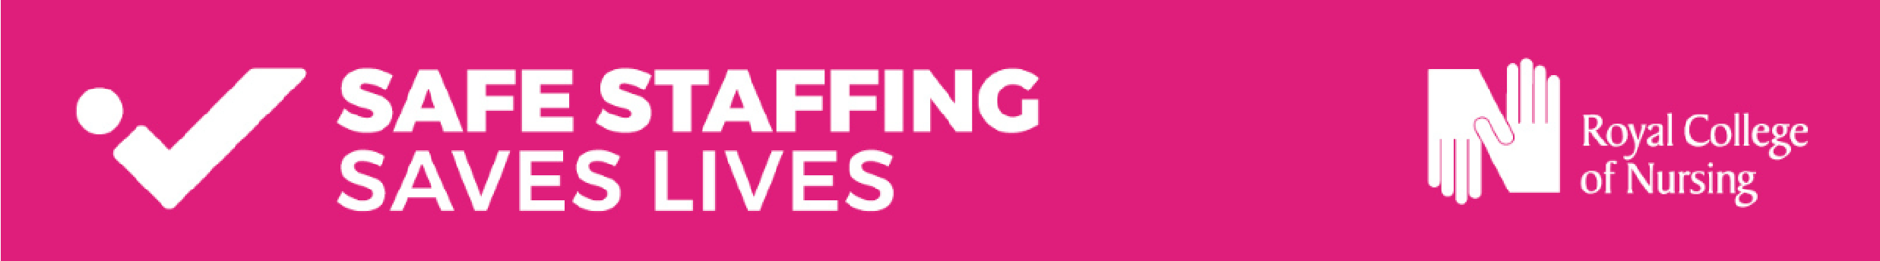
Know your rights: welfare facilities at work
Adequate welfare facilities for staff are an indicator of how valued staff are in the workplace, and the evidence links healthier, valued staff to better patient outcomes. That’s why it is so important that all nursing staff have access to suitable welfare facilities at work.
The information below comes from the NHS Staff Council and explains your rights to welfare facilities at work. Full details can be found here: https://www.nhsemployers.org/publications/welfare-facilities-healthcare-staff
The RCN Workforce Standards, particularly standard 13, may also be of use:
https://www.rcn.org.uk/-/media/Royal-College-Of-Nursing/Documents/Publications/2021/May/009-681.pdf


Drinking water: There must be a ‘readily accessible’ supply of drinking water, not only during break times but also during shifts. Employers have an obligation to provide clean drinking water for their workforce. Regulations require that "an adequate supply of wholesome drinking water shall be provided for all persons at work in the workplace." This supply shall "be readily accessible at suitable places' (Regulation 22 of the Workplace (Health, Safety and Welfare) Regulations 1992.


Facilities to rest and eat: Employers must provide suitable, readily accessible facilities to allow you to rest and eat meals. These areas should be away from your working environment, with adequate seating (complete with back support) for the number of persons at work likely to use them at any one time. Where hot food isn't readily available, there should be adequate facilities to allow you to store and heat up food. Special provisions need to be put in place for pregnant staff and nursing mothers. Facilities should be accessible to staff with disabilities. (Regulation 25 of the Workplace (Health, Safety and Welfare) Regulations 1992.
Changing facilities and lockers: Changing rooms should be provided for workers who change into special work clothing. They should ensure the occupier’s privacy and be accessible from your work area. There must be secure facilities for staff to store their clothing. Changing facilities should be fitted with adequate seating, clothing accommodation and showering facilities with accessible facilities for disabled staff. They should be large enough for the maximum number of workers expected to use them at any one time to do so. (Regulation 23 and 24 of the Workplace (Health, Safety and Welfare) Regulations 1992.

Sanitary and washing facilities: Washing facilities should have running hot and cold or warm water, soap and clean towels or other means of cleaning or drying. Where the work results in contamination of the skin by hazardous or offensive materials, suitable and sufficient showers should also be provided for staff to use. (Regulation 20 and 21 of the Workplace (Health, Safety and Welfare) Regulations 1992
Join the RCN online: rcn.org.uk/join
Already a member? Why not become a health and safety rep? https://www.rcn.org.uk/Get-Involved/rcn-reps
Advice and support for RCN members: 0345 772 6100
Name | Role and Ward | Signature

