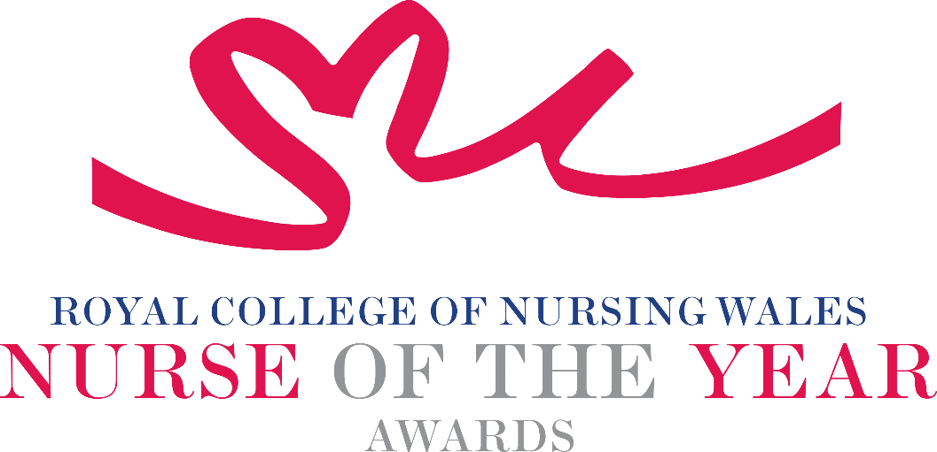

Chief Nursing Officer for Wales 2025 Criteria

Nominees for the Chief Nursing Officer Award will be Clinical Nursing or Midwifery Leaders who have demonstrated a significant contribution towards establishing ground-breaking patient safety schemes, developments in services, or initiating innovative change in nursing or midwifery practice. It should be evident that such schemes, projects, or innovations have had demonstrable benefits to person centred holistic care. The winner of this award will be inspirational and motivational, a pioneer in nursing or midwifery and a trailblazer of innovative practice.

About the Award: This award will celebrate the contribution of an exceptional nursing or midwifery leader in Wales, who by inspiring others and demonstrating exceptional leadership, has made a significant difference to person centred holistic care.

WHO CAN BE NOMINATED?
Registrants on all parts of the NMC register who are:
- In a leadership role at any level of practice or management settings within Wales.
- Practising in any sector for example: Independent Health and Social Care Sector, Third Sector, NHS or Local Authority.
- Diversity in nominees is encouraged to reflect the workforce in Wales.

CRITERIA
The nomination should consider and include details for each of the following criterion:
Leadership and Advocacy:
- Demonstrates exceptional leadership and collaboration in both nursing and midwifery and across sectors or professional disciplines, inspiring colleagues and influencing change within teams as well as beyond immediate areas of work.
- Advocates for person-centred holistic care in policy, practice and/or education and acts as a role model, mentoring and supporting others in providing compassionate care.
- Shows commitment to workforce development through mentorship, education or initiatives which future proof nursing and midwifery and a passion for the professions demonstrating a “can do” positive attitude.

Person-centred care excellence:
- Consistently delivers outstanding, individualised care that respects patient preferences, needs and values.
- Engages patients, families, and communities in shared decision-making and can demonstrate the benefits the work has had for patients, clients, families, and colleagues.
- Promotes dignity, respect and empowerment in all patient interactions.

Innovation & Impact:
- Demonstrates a positive contribution to innovation that has made a difference to clinical care and outcomes and demonstrates a contribution to sustainable delivery ensuring ongoing impact beyond initial implementation.
- Use of a credible evidence-base or developing an evidence base to under pin work for the project for which they are being nominated, using technology or data driven approaches to enhance nursing practice.
- Able to demonstrate a safe governance framework for the service or innovation being described for which they are being nominated

Professional & ethical practice:
- Fosters a culture of respect, inclusion and equity in healthcare settings.
- Maintains a commitment to lifelong learning and professional development.
- Leads quality improvement initiatives with measurable benefits for patients and staff.

TIPS FOR WRITING YOUR NOMINATION
- Consider if this is the best category to submit your nomination to, there are 14 different awards - Awards | Wales | Royal College of Nursing
- Every point you write should connect to the award criteria, this will help your nomination achieve a higher shortlisting score.
- Don’t assume reviewers will read between the lines—spell out how their work matters and how they promote positive patient care.
- Tell the reader what the headline is, what are you proud of? Use attention grabbing success stories.
- Avoid acronyms and use the spelling & grammar tool on word to check your nomination.
- Use at least 300 words but no more than 500 words.
- Make a draft with all your key points early. You can then review and write your full nomination when you have had time to consider the content.
- Speak with colleagues, gather real examples.

DRAFT NOMINATION NOTES

