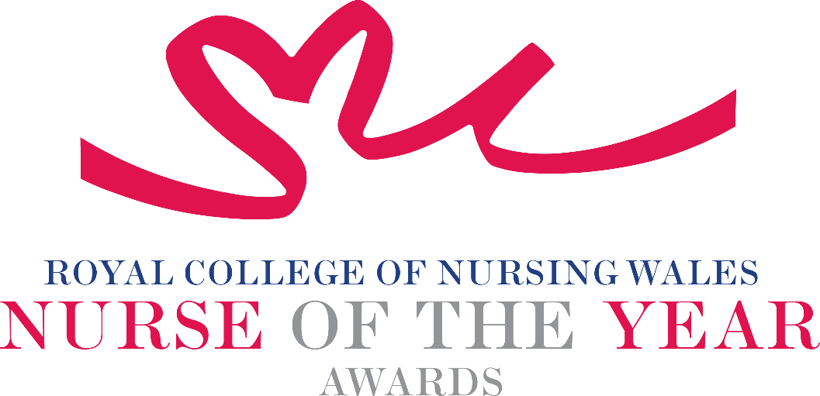

Community & Primary Care Nursing 2025 Criteria

Community & Primary Care Nurses and Midwives serve the health and nursing needs of all age groups in Welsh society and in all locations within the wider community, for example people’s own homes, schools, surgeries, clinics and within care homes.
Working collaboratively with key stakeholders, having a unique opportunity to serve the health and nursing needs of the local population, ranging from health promotion and prevention of ill health, early detection, management of chronic conditions and advanced practice. People receiving community-based care are increasingly more unwell and have more complex needs than ever before.
Nominations illustrating sustainability, continuity and consistency for people receiving primary or community-based care, are particularly welcome.

About the award: This award celebrates the achievements of all registrants of the NMC register who have made an outstanding contribution to the care of people in a primary or community-based setting.

WHO CAN BE NOMINATED?
Nurses registered on all parts of the NMC register who are:
- Working at any level within a clinical role or managing clinical services within Wales.
- Practising in any primary care or community setting, in any sector, for example: Independent Health and Social Care Sector, Third Sector, NHS or Local Authority.
- Diversity in nominees is encouraged to reflect the workforce in Wales.

CRITERIA

- Able to demonstrate that their work is commensurate with national policy and strategy within health and social care.
- Through effective leadership is able to demonstrate a positive contribution to an innovative development that has made a difference to people receiving care.
- Use of a credible evidence-base and / or are developing an evidence base to under pin their work for the project for which they are being nominated.
- Able to demonstrate a safe governance framework for the service or innovation being described for which they are being nominated.
- Able to clearly demonstrate the benefits the work has had for patients, clients, families and colleagues.
- Through service evaluation, patient involvement and / or other means, is able to demonstrate a positive impact.
- Show commitment to and passion for the nursing profession, going the “extra mile” demonstrating a “can do” positive attitude.

TIPS FOR WRITING YOUR NOMINATION
- Consider if this is the best category to submit your nomination to, there are 14 different awards - Awards | Wales | Royal College of Nursing
- Every point you write should connect to the award criteria, this will help your nomination achieve a higher shortlisting score.
- Don’t assume reviewers will read between the lines—spell out how their work matters and how they promote positive patient care.
- Tell the reader what the headline is, what are you proud of? Use attention grabbing success stories.
- Avoid acronyms and use the spelling & grammar tool on word to check your nomination.
- Use at least 300 words but no more than 500 words.
- Make a draft with all your key points early. You can then review and write your full nomination when you have had time to consider the content.
- Speak with colleagues, gather real examples.

DRAFT NOMINATION NOTES

