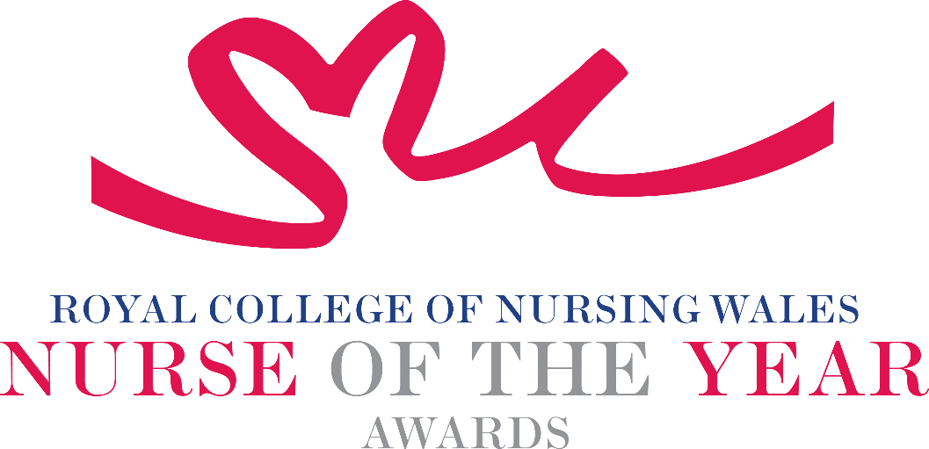

Health Care Support Worker 2025 Criteria

Health Care Support Workers are extremely valuable members of the nursing team. They work within the care home, hospital, community or independent sector under the guidance and supervision of Registered Nurses. Health Care Support Worker roles vary, depending on the area in which the person is working.

About the award: The award is open to any Health Care Support Worker, who has demonstrated commitment to providing high standards of care within nursing teams. They must work providing health or social care under the guidance and supervision of a registered nurse, midwife or health visitor and should not be on a professional register (such as NMC).

WHO CAN BE NOMINATED?
A Health Care Support Worker who is delegated work by a registered nurse, midwife or health visitor who is:

- Practising in any sector for example: Independent Health and Social Care Sector, Third Sector, NHS or Local Authority
- Diversity in nominees is encouraged to reflect the workforce in Wales

CRITERIA

- Able to demonstrate that their work is underpinned by local and national policy within health and social care
- Able to demonstrate a contribution to the innovative development of a service that has made a difference to people receiving care
- Use of an evidence-base and / or developing an evidence base to underpin their work for the project for which they are being nominated
- Able to clearly demonstrate the benefits the work has had for patients, clients, families and colleagues
- Is able to demonstrate a positive impact on safe and effective care as part of an service evaluation, patient involvement and / or other means
- Show commitment to and passion for the nursing and midwifery profession, going the “extra mile” demonstrating a “can do” positive attitude

TIPS FOR WRITING YOUR NOMINATION
- Consider if this is the best category to submit your nomination to, there are 14 different awards - Awards | Wales | Royal College of Nursing
- Every point you write should connect to the award criteria, this will help your nomination achieve a higher shortlisting score.
- Don’t assume reviewers will read between the lines—spell out how their work matters and how they promote positive patient care.
- Tell the reader what the headline is, what are you proud of? Use attention grabbing success stories.
- Avoid acronyms and use the spelling & grammar tool on word to check your nomination.
- Use at least 300 words but no more than 500 words.
- Make a draft with all your key points early. You can then review and write your full nomination when you have had time to consider the content.
- Speak with colleagues, gather real examples.

DRAFT NOMINATION NOTES

