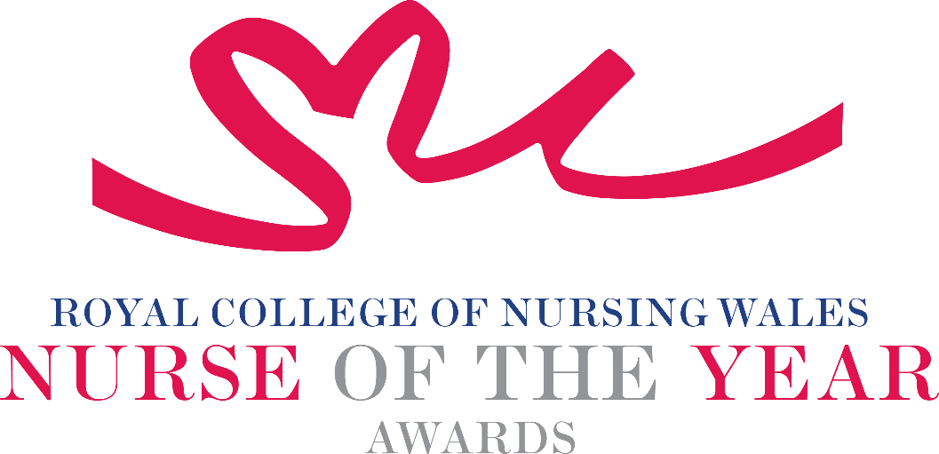

Improving Individual and Population Health
2025 Criteria

Health improvement can be achieved by working in partnership with individuals, communities and populations by nurses and midwives in all areas of nursing and midwifery practice. Opportunities to make an impact on improving or protecting the health of the population, spanning all age groups and can arise at individual, family, community, and national levels.

About the award: This award aims to recognise a nurse or midwife who has made an outstanding contribution to improving individual and/or population health, including the introduction of changes that lead to innovative health improvement or health protection interventions or programmes.

WHO CAN BE NOMINATED?
Nurses registered on all parts of the NMC register who are:
- Working in generic, specialist, leadership, academic or management roles within Wales
- Practising in any sector for example: Independent Health and Social Care Sector, Third Sector, NHS or Local Authority
- Diversity in nominees is encouraged to reflect the workforce in Wales

CRITERIA

- Able to demonstrate that their work relates to a relevant public health model or health framework and that the approach to promoting health and/or reducing the impact of disease or health harming behaviours is commensurate with national policy and strategy within health and social care
- Through effective leadership is able to demonstrate a central contribution to an innovative development that has made a difference to people receiving care and/or services
- Use of a credible evidence-base and / or developing an evidence base to under pin their work for the project for which they are being nominated
- Able to demonstrate a safe governance framework for the intervention, service or innovation being described for which they are being nominated
- Able to clearly demonstrate the benefits the work has had for patients, service users, families, communities and colleagues
- Through service evaluation, patient/service user involvement and / or other means, is able to demonstrate a positive impact on improving health
- Show commitment to and passion for the nursing profession, going the “extra mile” demonstrating a “can do” positive attitude

TIPS FOR WRITING YOUR NOMINATION
- Consider if this is the best category to submit your nomination to, there are 14 different awards - Awards | Wales | Royal College of Nursing
- Every point you write should connect to the award criteria, this will help your nomination achieve a higher shortlisting score.
- Don’t assume reviewers will read between the lines—spell out how their work matters and how they promote positive patient care.
- Tell the reader what the headline is, what are you proud of? Use attention grabbing success stories.
- Avoid acronyms and use the spelling & grammar tool on word to check your nomination.
- Use at least 300 words but no more than 500 words.
- Make a draft with all your key points early. You can then review and write your full nomination when you have had time to consider the content.
- Speak with colleagues, gather real examples.

DRAFT NOMINATION NOTES

