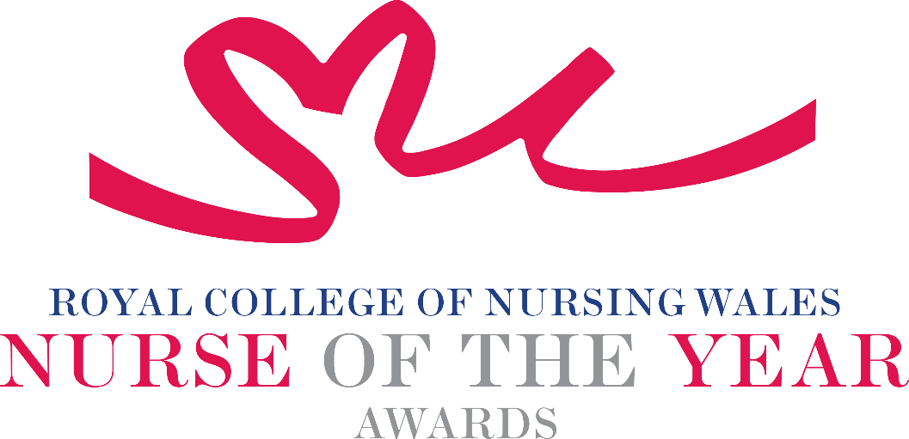

Lifetime Achievement 2025 Criteria

This award recognises an exceptional Registered Nurse who has made a career-long contribution to nursing practice, resulting in a legacy of sustainably improved outcomes for individuals, communities, and the wider population. This person will also have made a significant contribution to the development of nursing as a profession that is valued by society. Nominees for this award will be exemplary Registered Nurses, who have earned recognition from, and the respect of, their peers and will be acknowledged as having reached the pinnacle of their profession.

About the award: This award aims to recognise a truly exceptional Registered Nurse who is recognised as providing a lasting contribution to the nursing profession.

WHO CAN BE NOMINATED?
Registered Nurses who are:
- Working at any level within health and social settings (including, primary, community, care homes, other independent health and social care sectors, local authorities, and third sector) education, or management settings within Wales.
- Nominees must fulfil the criteria of the NMC registration at the time of nomination.

CRITERIA
- A nurse who has significantly improved patient care within their area of practice
- Recognised as having sustained accomplishments that have significantly advanced the status of nursing at a local, national, or international level.
- Able to demonstrate a track record of progressive leadership and will have inspired the advancement of nursing practice.
- Recognised as being an expert in their field, having delivered measurable improvements in the quality of care.
- Respected for the contribution that they have made to advancing the nursing profession through mentoring, supporting, and influencing the career development of other nurses and other health care practitioners.
- Able to demonstrate that their work is commensurate with national policy and strategy within health and social care.
- Through effective leadership can demonstrate a positive contribution to an innovative development that has made a difference to people receiving services.
- Use of a credible evidence-base and / or developing an evidence base to under pin their work for the project for which they are being nominated.
- Able to demonstrate a safe governance framework for the service or innovation being described for which they are being nominated.
- Able to clearly demonstrate the benefits the work has had for patients/ clients, families, communities, the wider population and colleagues.
- Through service evaluation, and / or other means, can demonstrate a positive impact.
- Show commitment to and passion for the nursing profession, going the “extra mile” demonstrating a “can do” positive attitude.

Please note:
For the Lifetime Achievement Award shortlisted candidates will not be required
to attend an interview

TIPS FOR WRITING YOUR NOMINATION
- Consider if this is the best category to submit your nomination to, there are 14 different awards - Awards | Wales | Royal College of Nursing
- Every point you write should connect to the award criteria, this will help your nomination achieve a higher shortlisting score.
- Don’t assume reviewers will read between the lines—spell out how their work matters and how they promote positive patient care.
- Tell the reader what the headline is, what are you proud of? Use attention grabbing success stories.
- Avoid acronyms and use the spelling & grammar tool on word to check your nomination.
- Use at least 300 words but no more than 500 words.
- Make a draft with all your key points early. You can then review and write your full nomination when you have had time to consider the content.
- Speak with colleagues, gather real examples.

DRAFT NOMINATION NOTES

