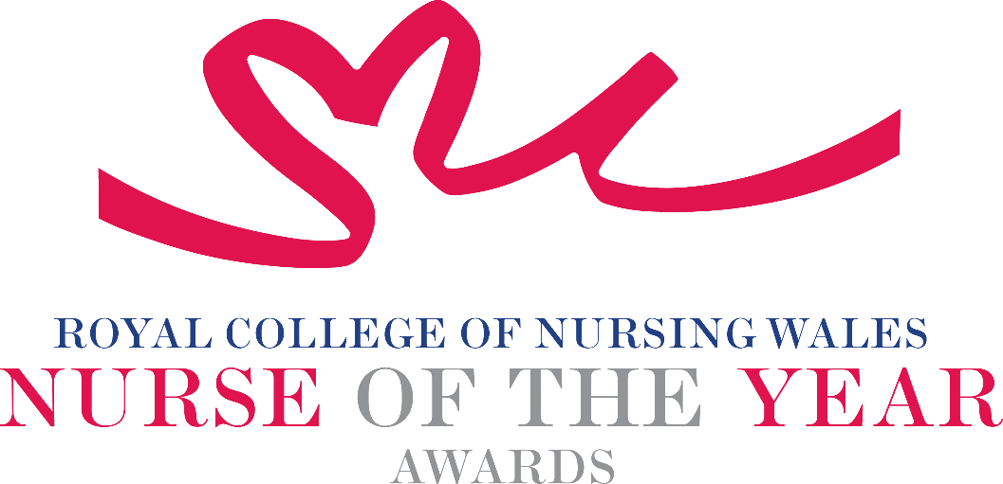

Nurse Education 2025 Criteria

This award is open to Registered Nurses working in nursing practice, education or management roles within Wales who develop and/ or deliver high quality education to those who deliver health and/ or social care, to include outstanding supervisor and/or assessor/practice education facilitators. Nominees for the Award will demonstrate the use of innovative teaching and/ or facilitative methods to maximise learning.

About the award: This award recognises an outstanding Registered Nurse who will have made a significant difference to the development and or delivery of high-quality education to those who deliver/ aim to deliver health care.

WHO CAN BE NOMINATED?
Registered Nurses who are:
- Working at any level in practice education or management settings within Wales
- Practising in any sector for example: Independent Health and Social Care Sector, Third Sector, NHS or Local Authority
- Diversity in nominees is encouraged to reflect the workforce in Wales

CRITERIA

- Through effective leadership can demonstrate a positive contribution to an innovative development that has made a difference to those receiving supervision assessments/teaching and learning, and therefore, people receiving care
- Able to demonstrate a central contribution to the development of an evaluated education programme or initiative that has made a difference to learners and therefore patients
- Will be able to demonstrate that their approach to education is commensurate with national policy and strategy within health and social care
- Must be able to show that their educational approach or product is underpinned by an appropriate evidence base
- Should be able to demonstrate that their work supports a relevant educational framework and/or approach
- Through service evaluation, patient involvement and / or other means, is able to demonstrate a positive impact
- Able to demonstrate a positive impact on the clinical practice, confidence and professionalism of the individual being supervised/assessed
- Show commitment to and passion for the nursing profession, going the “extra mile” demonstrating a “can do” positive attitude.

TIPS FOR WRITING YOUR NOMINATION
- Consider if this is the best category to submit your nomination to, there are 14 different awards - Awards | Wales | Royal College of Nursing
- Every point you write should connect to the award criteria, this will help your nomination achieve a higher shortlisting score.
- Don’t assume reviewers will read between the lines—spell out how their work matters and how they promote positive patient care.
- Tell the reader what the headline is, what are you proud of? Use attention grabbing success stories.
- Avoid acronyms and use the spelling & grammar tool on word to check your nomination.
- Use at least 300 words but no more than 500 words.
- Make a draft with all your key points early. You can then review and write your full nomination when you have had time to consider the content.
- Speak with colleagues, gather real examples.

DRAFT NOMINATION NOTES

