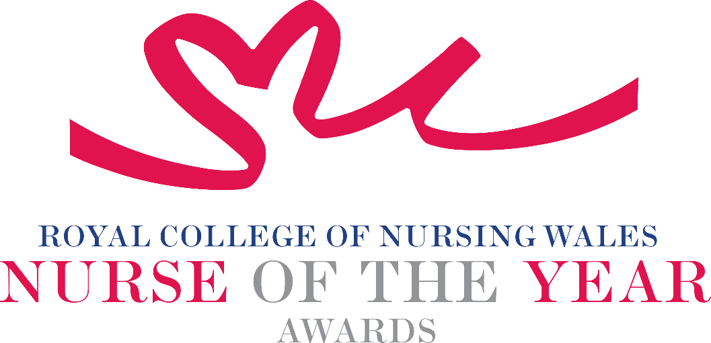

Nursing Student 2025 Criteria

Becoming a Registered Nurse/midwife is the culmination of years of study, hard work and dedication as a student. Students must attain both clinical and academic competence in order to secure their registration with the Nursing & Midwifery Council. Nursing Students in Wales are educated at degree level in a chosen field of practice. Nominees for this award will deserve recognition for exceptional achievement during their years of study, for instance, having shown exceptional academic or clinical ability, or have been seen to be particularly compassionate and caring during their clinical placements, signalling a promising career ahead of them.

About the award: This award aims to recognise Nursing / Midwifery students who have shown exceptional promise during their professional education and / or practice placements.

WHO CAN BE NOMINATED?
The nominee must be a student nurse or student midwife studying in Wales at the time of nomination.

CRITERIA

- Must be a student nurse or student midwife who has made a significant difference to the patient care of a client group within their chosen field during the course of their studies.
- Deserve recognition for exceptional achievement during their years of study (for instance, they may have shown exceptional academic or clinical ability, or have been seen to be particularly compassionate and caring during their clinical placements).
- Demonstrate use of a credible evidence-base and / or developing an evidence base to under pin their work for the project for which they are being nominated.
- Able to demonstrate that their work is commensurate with national policy and strategy within health and social care.
- Show commitment to and passion for the nursing profession, going the “extra mile” demonstrating a “can do” positive attitude.

TIPS FOR WRITING YOUR NOMINATION
- Consider if this is the best category to submit your nomination to, there are 14 different awards - Awards | Wales | Royal College of Nursing
- Every point you write should connect to the award criteria, this will help your nomination achieve a higher shortlisting score.
- Don’t assume reviewers will read between the lines—spell out how their work matters and how they promote positive patient care.
- Tell the reader what the headline is, what are you proud of? Use attention grabbing success stories.
- Avoid acronyms and use the spelling & grammar tool on word to check your nomination.
- Use at least 300 words but no more than 500 words.
- Make a draft with all your key points early. You can then review and write your full nomination when you have had time to consider the content.
- Speak with colleagues, gather real examples.

DRAFT NOMINATION NOTES

