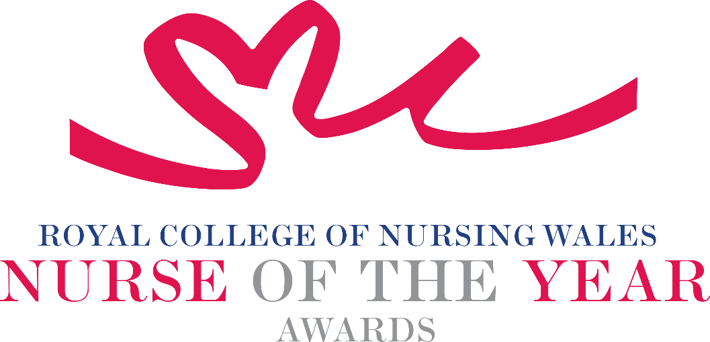

Research, Innovation and Digitalisation in Nursing
2025 Criteria

Nursing research, innovation and digitalisation provide the evidence that underpins nursing and midwifery practice. Spanning all age ranges and across the health spectrum from early years, to enhancing wellbeing and to end of life care - nursing research, innovation and digitalisation play a crucial role in advancing practice. They are essential components of modern nursing to stimulate the quality of care for people in ways that promote a values-based approach, that consider patient-centred care and consider the wider aspects of cost-effectiveness, improvements in health and care, whilst creating systems and services that are more accessible and sustainable.

About the award: This award seeks to recognise and reward excellence in nursing and midwifery where research, innovation or digitalisation (including preliminary work such as pilot studies, clinical audits, or service improvement) has demonstrated tangible benefits to patient care. It acknowledges nurses and midwives who have enhanced the patient experience through their evidence-based innovations which have driven and/or influenced change. These changes may have introduced the creation and implementation of digital services to complete processes. Nominators are required to submit a clear narrative detailing the development or implementation of the research, transformation, or service improvement, including the methodology used and how the changes have positively impacted the patient experience and outcomes of care.

WHO CAN BE NOMINATED?
Registrants on all parts of the NMC register who are:

- Working at any level within a clinical role or managing clinical services within Wales.
- Engaged in research, clinical audit or service improvement / innovation within any health care, social care or research environment.
- Practising in any sector for example: Independent Health and Social Care, Third Sector, NHS or Local Authority.
- Diversity in nominees is encouraged to reflect today’s workforce in Wales.

CRITERIA

- Able to demonstrate that their work is commensurate with national policy and strategy within health and social care.
- Demonstrates outstanding contribution to, or application of, research clinical audit, service improvement, innovation or digitalisation.
- Able to demonstrate a positive contribution to an innovative development that has made a tangible difference to people receiving care.
- Promotes an evidence-based approach to innovation within their sphere of practice.
- Shows an active engagement in dissemination of research through presentations, publications or other means of dissemination, or have documented contributions of research, research and development, clinical audit or service innovation within the national context of Wales.
- Able to demonstrate a safe governance framework for the research, innovation or digitalisation being described for which they are being nominated.
- Evidence of leadership in strengthening the profile of nursing and midwifery research.
- Through service evaluation, patient involvement and / or other means, able to demonstrate a positive impact to those in their care.
- Clear commitment to and passion for the nursing profession, going the “extra mile” demonstrating a “can do” positive attitude.

TIPS FOR WRITING YOUR NOMINATION
- Consider if this is the best category to submit your nomination to, there are 14 different awards - Awards | Wales | Royal College of Nursing
- Every point you write should connect to the award criteria, this will help your nomination achieve a higher shortlisting score.
- Don’t assume reviewers will read between the lines—spell out how their work matters and how they promote positive patient care.
- Tell the reader what the headline is, what are you proud of? Use attention grabbing success stories.
- Avoid acronyms and use the spelling & grammar tool on word to check your nomination.
- Use at least 300 words but no more than 500 words.
- Make a draft with all your key points early. You can then review and write your full nomination when you have had time to consider the content.
- Speak with colleagues, gather real examples.

DRAFT NOMINATION NOTES

