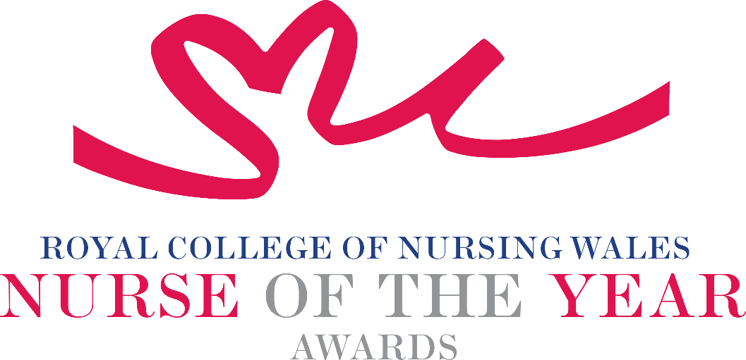

Registered Nurse - Adult 2025 Criteria

Registered Nurses working with adults operate in a dynamic clinical environment which is constantly changing not least to embrace innovations in healthcare technology and advancements in research and best practice. Providing care to adults who need clinical nursing care, practicing in a variety of care settings.

About the award: This award aims to recognise an exceptional Registered Adult Nurse who is being recognised for their innovative and creative approach to the care of adults.

WHO CAN BE NOMINATED?
A Registered Nurse (Adult) who is:
- Working at any level within a clinical role or managing clinical services within Wales
- Practising in any sector for example: Independent Health and Social Care Sector, Third Sector, NHS or Local Authority
- Diversity in nominees is encouraged to reflect the workforce in Wales

CRITERIA
- Able to demonstrate that their work relates national policy and strategy within health and/or social care.
- Through effective leadership can demonstrate a positive contribution to an innovative development that has made a difference to people receiving care.
- Use of a credible evidence-base and / or developing an evidence base to under pin their work for the project for which they are being nominated.
- Able to demonstrate a safe governance framework for the service or innovation being described for which they are being nominated.
- Able to clearly demonstrate benefits the work has had for patients, clients, families and colleagues.
- Through service evaluation, patient involvement and / or other means, can demonstrate a positive impact.
- Shares this work/ project with colleagues for the purpose of learning, demonstrating leadership qualities that reflect the NMC Code of Practice.
- Show commitment to and passion for the nursing profession, going the “extra mile”, demonstrating a “can do” positive attitude.

TIPS FOR WRITING YOUR NOMINATION
- Consider if this is the best category to submit your nomination to, there are 14 different awards - Awards | Wales | Royal College of Nursing
- Every point you write should connect to the award criteria, this will help your nomination achieve a higher shortlisting score.
- Don’t assume reviewers will read between the lines—spell out how their work matters and how they promote positive patient care.
- Tell the reader what the headline is, what are you proud of? Use attention grabbing success stories.
- Avoid acronyms and use the spelling & grammar tool on word to check your nomination.
- Use at least 300 words but no more than 500 words.
- Make a draft with all your key points early. You can then review and write your full nomination when you have had time to consider the content.
- Speak with colleagues, gather real examples.

DRAFT NOMINATION NOTES

