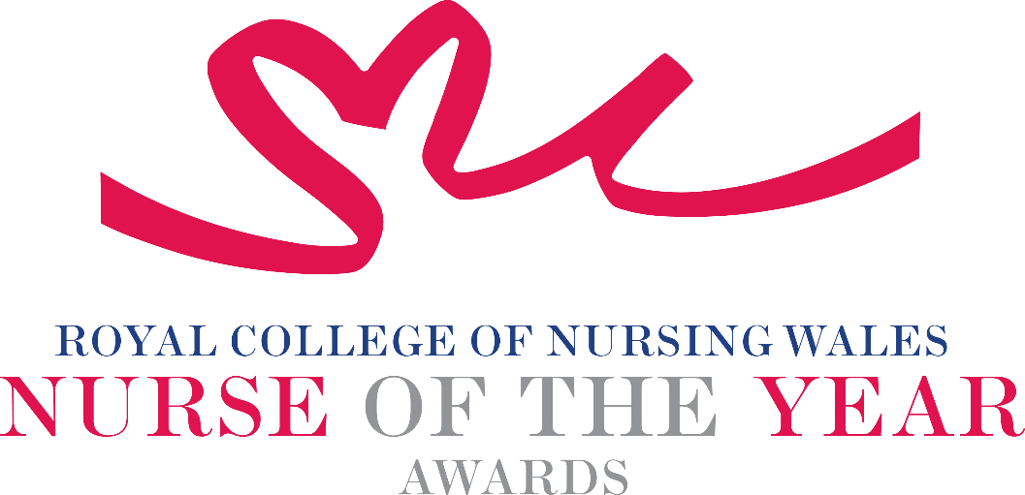

Registered Nurse – Child 2025 Criteria

Nominees for this award will be one of the following:

Children’s nurses meet the health needs of children and young people. They play a key role in assessing children's nursing needs and other healthcare needs, considering their medical, social, cultural and family circumstances. They then plan and deliver care in a variety of settings, within hospitals, hospices and in the wider community. In addition to supporting children and young people, children’s nurses work with families as part of a multidisciplinary team.

Midwives play a lead role in supporting pregnant women and new mothers. They practise in both hospital and community settings. Midwives are involved in all aspects of antenatal, intrapartum and postnatal care. They are skilled at supporting new and prospective parents.

About the award: This award aims to recognise a Registered Nurse or Registered Midwife who has made an outstanding contribution to the care of children, young people or the midwifery care of mothers-to-be/ parent/s.

WHO CAN BE NOMINATED?
Either a Registered Nurse or Registered Midwife who are working in the paediatric field:
- Working at any level within a clinical role or managing clinical services within Wales.
- Practising in any sector for example: NHS, Independent Health and Social Care Sector, Third Sector, or Local Authority.
- Diversity in nominees is encouraged to reflect the workforce in Wales.
CRITERIA
- Able to demonstrate that their work is commensurate with national policy and strategy within health and social care.
- Through effective leadership is able to demonstrate a positive contribution to an innovative development that has made a difference to people receiving care
- Use of a credible evidence-base and / or are developing an evidence base to under pin their work for the project for which they are being nominated.
- Able to demonstrate a safe governance framework for the service or innovation being described for which they are being nominated.
- Able to clearly demonstrate the benefits the work has had for patients, clients, families and colleagues.
- Through service evaluation, patient involvement and / or other means, is able to demonstrate a positive impact.
- Able to demonstrate leadership of an approach which promotes the public health agenda and supports healthy living within the family and/or population served.
- Show commitment to and passion for the nursing and midwifery profession, going the “extra mile” demonstrating a “can do” positive attitude.
- Able to demonstrate a passion for children’s rights and the willingness to advocate

TIPS FOR WRITING YOUR NOMINATION
- Consider if this is the best category to submit your nomination to, there are 14 different awards - Awards | Wales | Royal College of Nursing
- Every point you write should connect to the award criteria, this will help your nomination achieve a higher shortlisting score.
- Don’t assume reviewers will read between the lines—spell out how their work matters and how they promote positive patient care.
- Tell the reader what the headline is, what are you proud of? Use attention grabbing success stories.
- Avoid acronyms and use the spelling & grammar tool on word to check your nomination.
- Use at least 300 words but no more than 500 words.
- Make a draft with all your key points early. You can then review and write your full nomination when you have had time to consider the content.
- Speak with colleagues, gather real examples.

DRAFT NOMINATION NOTES

