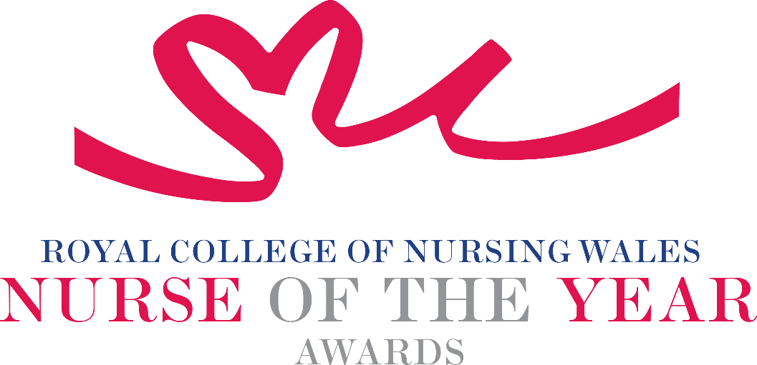

Registered Nurse - Mental Health 2025 Criteria

Mental Health Nurses work with people of all ages, from childhood through adulthood to old age. As well as supporting people with mental illness, they have an important role to play in the mental health promotion of individuals and the wider community. Mental Health Nurses work as part of wider multidisciplinary and interagency teams to plan and deliver mental healthcare, ranging from promoting emotional and mental wellbeing through to supporting people with acute mental illness.

About the award: This award aims to recognise an exceptional Registered Mental Health Nurse who is being recognised for their innovative and creative approach to the care of people within these specialities.

WHO CAN BE NOMINATED?
Registered Mental Health Nurses who are:

- Working at any level within a clinical role or managing clinical services within Wales.
- Practising in any sector for example: Independent Health and Social Care Sector, Third Sector, NHS or Local Authority.
- May be working with children, young people, adults or older people.
- Diversity in nominees is encouraged to reflect the workforce in Wales.

CRITERIA

- Able to demonstrate that their work is commensurate with national policy and strategy within health and social care.
- Through effective leadership is able to demonstrate a positive contribution to an innovative development that has made a difference to people receiving care.
- Use of a credible evidence-base and / or developing an evidence base to under pin their work for the project for which they are being nominated.
- Able to demonstrate a safe governance framework for the service or innovation being described for which they are being nominated.
- Able to clearly demonstrate the benefits the work has had for patients, clients, families and colleagues.
- Through service evaluation, patient involvement and / or other means, is able to demonstrate a positive impact.
- Show commitment to and passion for the nursing profession, going the “extra mile” demonstrating a “can do” positive attitude.

TIPS FOR WRITING YOUR NOMINATION
- Consider if this is the best category to submit your nomination to, there are 14 different awards - Awards | Wales | Royal College of Nursing
- Every point you write should connect to the award criteria, this will help your nomination achieve a higher shortlisting score.
- Don’t assume reviewers will read between the lines—spell out how their work matters and how they promote positive patient care.
- Tell the reader what the headline is, what are you proud of? Use attention grabbing success stories.
- Avoid acronyms and use the spelling & grammar tool on word to check your nomination.
- Use at least 300 words but no more than 500 words.
- Make a draft with all your key points early. You can then review and write your full nomination when you have had time to consider the content.
- Speak with colleagues, gather real examples.

DRAFT NOMINATION NOTES

