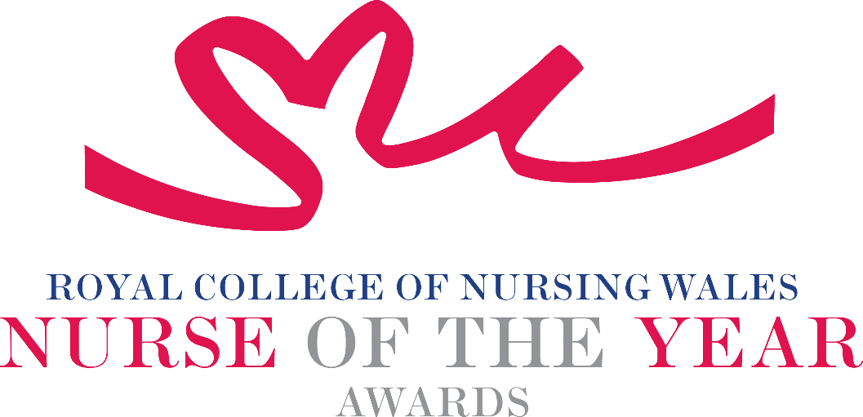

Specialist Nursing of 2025 Criteria

Nurses undertaking advanced and specialist practice can be found in all areas of clinical practice. These roles are typified using specialist clinical skills and can include leading, organising and delivering complex care across multi-professions and services.

About the award: This award aims to recognise nurses undertaking advanced and specialist practice who make an outstanding contribution to patient care, including the introduction of changes that lead to innovative programmes of care.

For this award, advanced and specialist are as defined in the Professional Framework for Enhanced, Advanced and Consultant Clinical Practice in Wales (https://heiw.nhs.wales/workforce/workforce-development/introducing-advanced-practice/) or in the case of the former, credentialed by the Royal College of Nursing https://www.rcn.org.uk/professional-development/professional-services/credentialing

WHO CAN BE NOMINATED?
Nurses registered on all parts of the NMC register who are:
- Working at an advanced and specialist level in a clinical role within Wales, supported by post graduate qualification/s commensurate to the scope of practice.
- Practising in any sector for example: Independent Health and Social Care Sector, Third Sector, NHS or Local Authority.
- Diversity in nominees is encouraged to reflect the workforce in Wales.
CRITERIA

- Able to demonstrate that their work is commensurate with national policy and strategy within health and social care.
- Through effective leadership is able to demonstrate a positive contribution to an innovative development that has made a difference to people receiving care.
- Use of a credible evidence-base and / or are developing an evidence base to under pin their work for the project for which they are being nominated.
- Able to demonstrate a safe governance framework for the service or innovation being described for which they are being nominated.
- Able to clearly demonstrate the benefits the work has had for patients, clients, families and colleagues.
- Through service evaluation, patient involvement and / or other means, is able to demonstrate a positive impact.
- Show commitment to and passion for the nursing profession, going the “extra mile” demonstrating a “can do” positive attitude.

TIPS FOR WRITING YOUR NOMINATION
- Consider if this is the best category to submit your nomination to, there are 14 different awards - Awards | Wales | Royal College of Nursing
- Every point you write should connect to the award criteria, this will help your nomination achieve a higher shortlisting score.
- Don’t assume reviewers will read between the lines—spell out how their work matters and how they promote positive patient care.
- Tell the reader what the headline is, what are you proud of? Use attention grabbing success stories.
- Avoid acronyms and use the spelling & grammar tool on word to check your nomination.
- Use at least 300 words but no more than 500 words.
- Make a draft with all your key points early. You can then review and write your full nomination when you have had time to consider the content.
- Speak with colleagues, gather real examples.

DRAFT NOMINATION NOTES

