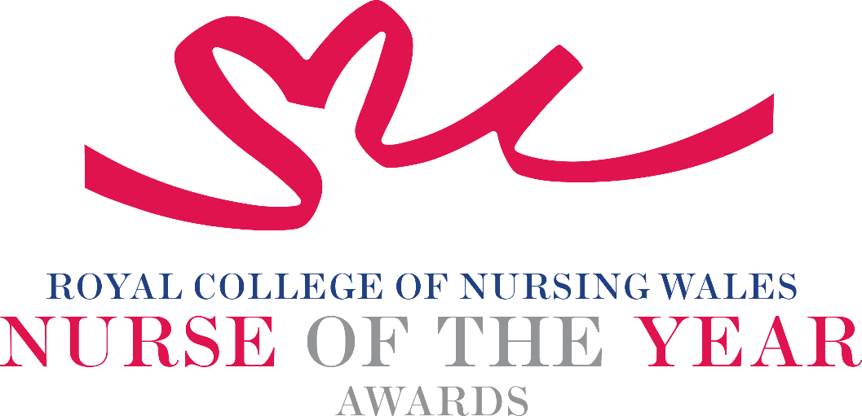

Chief Nursing Officer for Wales Award 2026
Inclusive Leadership Award - Celebrating Equity, Diversity & System Impact

The Chief Nursing Officer for Wales Inclusive Leadership Award recognises clinical Nursing or Midwifery leaders who have made an exceptional and sustained contribution to creating inclusive, equitable and empowered environments for both the workforce and those accessing care across Wales.
This award celebrates leaders who not only deliver excellence in person-centred care and innovation, but who also actively champion equity across all protected characteristics, ensuring that diversity is valued, discrimination is challenged, and systemic barriers are removed. This aligns directly with the CNO Strategic Vision 2025 - 2030, including its commitments to a valued workforce, empowered leadership, and evidence driven improvement.

In recognition of Wales’s national transition from the Workforce Race Equality Standard (WRES) to the Workforce Equality Standard (WES), which expands equality monitoring and action planning across all protected characteristics, this award also honours leaders who use insight, data and inclusive practice to improve workplace experience and outcomes for diverse staff groups. The WES framework reflects Welsh Government’s objective to understand and improve the lived experience of health and care staff holistically, and to drive meaningful cultural change.

About the Winner
The winner will be an inspirational and influential leader in Wales who models compassionate, inclusive and courageous leadership. They will be committed to driving cultural, professional and system-wide transformation that enhances care experience, strengthens equity, and enables both colleagues and communities to thrive.

They will be known for:
- Creating psychologically safe, empowering environments
- Breaking down barriers to inclusion and participation
- Delivering innovative, evidence informed practice
- Leading change that benefits individuals, teams, organisations and communities
- Embodying the values of dignity, respect, fairness and belonging

Who Can Be Nominated?
Registrants on any part of the NMC register who are:
- In a leadership role at any level in any practice or management setting within Wales
- Working in any sector (e.g., NHS, Local Authority, Primary Care, Third Sector, Independent Sector)
- Demonstrating leadership that reflects the diversity of Wales’s nursing and midwifery workforce
Inclusivity and diversity of nominees is strongly encouraged.
Criteria
Nominations should include clear examples and outcomes for each of the following:

1. Inclusive Leadership & Advocacy
- Champions equity, dignity, respect and belonging across all protected characteristics.
- Advocates for inclusive policies, cultures and practices that reduce disparities.
- Acts as a visible leader supporting the Strategic Vision’s aim of a valued, respected workforce.
- Role models psychological safety, allyship and anti‑discriminatory behaviours.

2. Person-Centred, Equitable Care Excellence
- Provides compassionate, culturally safe, individualised care that meets diverse needs.
- Improves access and outcomes for underrepresented or disadvantaged groups.
- Builds trust and shared decision‑making with people, families and communities.
- Aligns with the Strategic Vision’s focus on population‑based and preventative care.

3. Innovation & Impact for Inclusion
- Leads innovation that addresses inequity or improves inclusion/accessibility.
- Uses research, evidence, data and WES insights to identify disparities and design solutions.
- Demonstrates measurable, sustainable improvements for patients, staff or communities.
- Supports Strategic Vision priorities for research, data, digital innovation and evidence‑based practice.

4. Workforce Development, Empowerment & Culture Change
- Improves representation, development and progression for diverse staff groups.
- Enhances wellbeing, belonging and fair treatment across teams.
- Builds colleagues’ confidence and capability to lead inclusively and challenge discrimination.
- Aligns with WES aims to strengthen workforce equity across all protected characteristics.

5. Professional, Ethical & Globally Minded Practice
- Upholds high ethical, respectful and professional standards.
- Champions anti‑racist, anti‑discriminatory and equality‑driven practice.
- Contributes to Wales’s global nursing/midwifery leadership ambitions.
- Shows ongoing personal and professional development with an equity focus.

6. Workforce Equality Standard (WES) Alignment
- Uses WES/WRES‑aligned data to identify and tackle workforce disparities.
- Demonstrates leadership across WES domains (representation, CPD equity, fair processes, anti‑bullying culture).
- Embeds inclusive culture change through evidence, transparency and accountability.

PLEASE NOTE THAT NOMINATIONS WILL BE SCORED USING EACH OF THE ABOVE CRITERIA POINTS, INDIVIDUALLY.

TIPS FOR WRITING YOUR NOMINATION
- Consider if this is the best category to submit your nomination to, there are 14 different awards - Awards | Wales | Royal College of Nursing
- Every point you write should connect to the award criteria, this will help your nomination achieve a higher shortlisting score.
- Don’t assume reviewers will read between the lines—spell out how their work matters and how they promote positive patient care.
- Tell the reader what the headline is, what are you proud of? Use attention grabbing success stories.
- Avoid acronyms and use the spelling & grammar tool on word to check your nomination.
- Use at least 300 words but no more than 500 words.
- Make a draft with all your key points early. You can then review and write your full nomination when you have had time to consider the content.
- Speak with colleagues, gather real examples.

DRAFT NOMINATION NOTES

