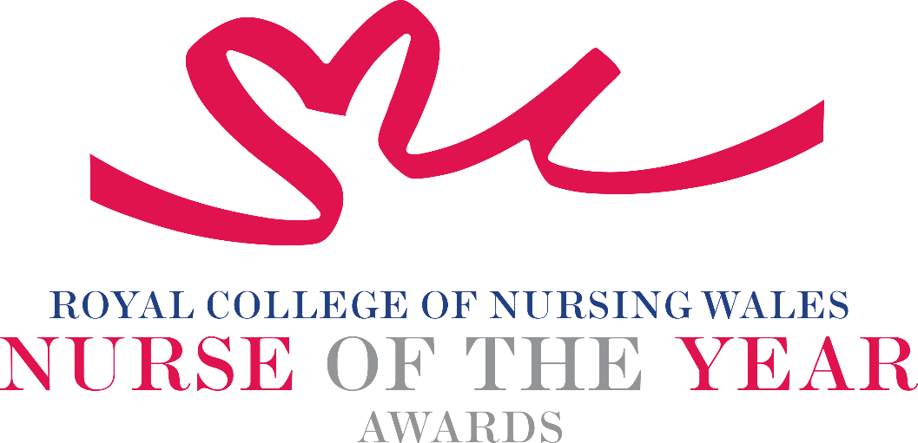

Nursing Student 2026 Criteria

Becoming a Registered Nurse/midwife is the culmination of years of study, hard work and dedication as a student. Students must attain both clinical and academic competence in order to secure their registration with the Nursing & Midwifery Council. Nursing Students in Wales are educated at degree level in a chosen field of practice. Nominees for this award will deserve recognition for exceptional achievement during their years of study, for instance, having shown exceptional academic or clinical ability, or have been seen to be particularly compassionate and caring during their clinical placements, signalling a promising career ahead of them.

About the award: This award aims to recognise Nursing / Midwifery students who have shown exceptional promise during their professional education and / or practice placements.

WHO CAN BE NOMINATED?
The nominee must be a student nurse or student midwife studying in Wales at the time of nomination.

CRITERIA
A nominee should be able to show that:

- Must be a student nurse or student midwife who has made a real, positive difference to the care of a group of patients during their training
- Should be recognised for outstanding achievement during their studies — for example, showing excellent academic or clinical skills, or being especially caring and compassionate during placements.
- Their work follows national health and social care policy and strategy.
- They use evidence to support their work, or they are helping to build an evidence base for the project they are nominated for.
- They show passion and commitment for the nursing profession, consistently goes the extra mile and maintains a positive, “can‑do” attitude.

PLEASE NOTE THAT NOMINATIONS WILL BE SCORED USING EACH OF THE ABOVE CRITERIA POINTS, INDIVIDUALLY.

TIPS FOR WRITING YOUR NOMINATION
- Consider if this is the best category to submit your nomination to, there are 14 different awards - Awards | Wales | Royal College of Nursing
- Every point you write should connect to the award criteria, this will help your nomination achieve a higher shortlisting score.
- Don’t assume reviewers will read between the lines—spell out how their work matters and how they promote positive patient care.
- Tell the reader what the headline is, what are you proud of? Use attention grabbing success stories.
- Avoid acronyms and use the spelling & grammar tool on word to check your nomination.
- Use at least 300 words but no more than 500 words.
- Make a draft with all your key points early. You can then review and write your full nomination when you have had time to consider the content.
- Speak with colleagues, gather real examples.

DRAFT NOMINATION NOTES

