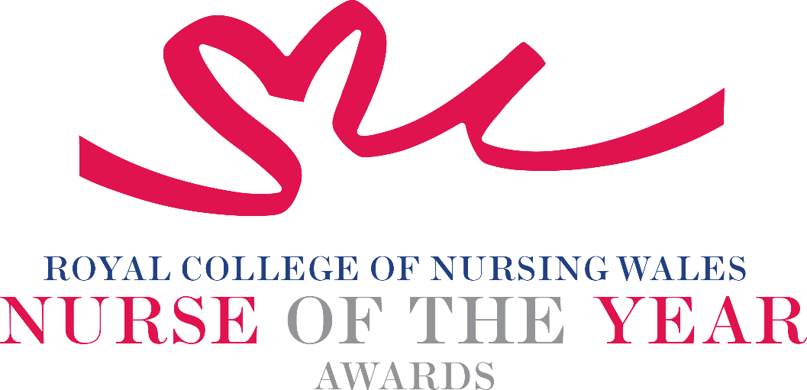

Registered Nurse - Learning Disabilities 2026 Criteria

Learning Disability Nurses aim to support the wellbeing and social inclusion of people with learning disabilities to maintain and maximise physical and mental health. They also work to reduce the barriers to social inclusion, so supporting the individual to pursue a fulfilling life.

About the award: This award aims to recognise an exceptional Registered Learning Disability Nurse who is being recognised for their innovative and creative approach to the care of people within this speciality.

WHO CAN BE NOMINATED?
Registered Learning Disability Nurses who are:
- Working at any level within a clinical role or managing clinical services within Wales.
- Practising in any sector for example: Independent Health and Social Care Sector, Third Sector, NHS or Local Authority.
- May be working with children, young people, adults or older people.
- Diversity in nominees is encouraged to reflect the workforce in Wales.

CRITERIA
A nominee should be able to show that:

- Their work follows national health and social care policy and strategy.
- Through strong leadership, they have contributed to a new and original development that has made a real difference to people receiving care.
- They use evidence to support their work, or they are helping to build an evidence base for the project they are nominated for.
- They can show that the service or innovation they are nominated for has a safe and effective governance framework.
- Their work has clearly benefited patients, clients, families and colleagues.
- They have made a positive impact on safe and effective care, demonstrated through service evaluation, patient feedback or other methods.
- They show passion and commitment for the nursing profession, consistently goes the extra mile and maintains a positive, “can‑do” attitude.

PLEASE NOTE THAT NOMINATIONS WILL BE SCORED INDIVIDUALLY USING EACH OF THE ABOVE CRITERIA POINTS.
TIPS FOR WRITING YOUR NOMINATION
- Consider if this is the best category to submit your nomination to, there are 14 different awards - Awards | Wales | Royal College of Nursing
- Every point you write should connect to the award criteria, this will help your nomination achieve a higher shortlisting score.
- Don’t assume reviewers will read between the lines—spell out how their work matters and how they promote positive patient care.
- Tell the reader what the headline is, what are you proud of? Use attention grabbing success stories.
- Avoid acronyms and use the spelling & grammar tool on word to check your nomination.
- Use at least 300 words but no more than 500 words.
- Make a draft with all your key points early. You can then review and write your full nomination when you have had time to consider the content.
- Speak with colleagues, gather real examples.

DRAFT NOMINATION NOTES

